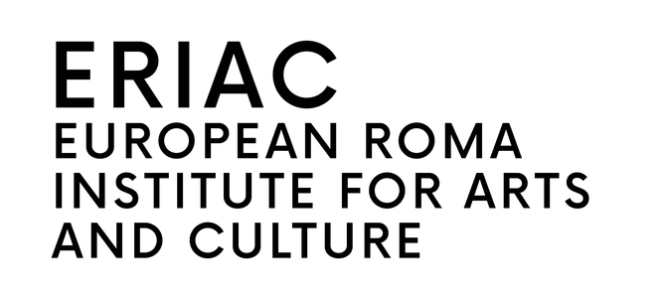
PRESS RELEASE · FOR IMMEDIATE RELEASE
Šuto Orizari marks 30 years with a community and music festival
Mashkari Amende (Among Us), 11–12 September 2026, marks 30 years of the Municipality of Šuto Orizari with two days of workshops, an exhibition and Romani poetry, closing with an open-air music festival on the Municipality Square. Headlining: acclaimed Roma Macedonian multi-instrumentalist Bajsa Arifovska with her project Dialektika. Free admission.
Šuto Orizari, Skopje, North Macedonia, 11–12 September 2026 — The European Roma Institute for Arts and Culture (ERIAC), in partnership with the Municipality of Šuto Orizari, presents Mashkari Amende (Among Us), a two-day community and music festival taking place on the occasion of the municipality’s 30th anniversary. The programme celebrates the culture, heritage and creativity of Šuto Orizari — known to its residents as Šutka — across two days of workshops, an exhibition, Romani poetry and an open-air music festival. Admission is free.
The festival opens on 11 September with a community day for the children and young people of Šutka, held at the Primary School “Brothers Ramiz and Hamid”. On 12 September the programme continues with an afternoon of cultural exchange at the Municipality of Šuto Orizari, and concludes with an evening of live music on the Municipality Square.
Mashkari Amende forms part of ERIAC’s work to strengthen Roma community pride and identity: creating platforms on which Roma communities present their own culture on their own terms, enabling young people to encounter Roma art and heritage as a living practice, and advancing the recognition of Roma history and cultural production as part of European cultural heritage.
The evening festival is headlined by the acclaimed Roma Macedonian multi-instrumentalist Bajsa Arifovska, who presents her project Dialektika — a musical encounter between Balkan, Mediterranean, North African and Romani traditions — accompanied by Polis Efraimidis (Greece), Kari Ikonen (Finland) and Damir Mazrek (Slovenia). She is joined on the programme by the Roma Rock School Band, young Roma musicians from Šuto Orizari, the Gipsy Groove Band from Kosovo, and DJ Bato.
Day 1 · 11 September · Community Day
The festival opens with a day for children and teenagers at the Primary School “Brothers Ramiz and Hamid”, with workshops led by artists and cultural practitioners.
• Textile Heroes — children make fabric panels honouring Roma figures who inspire them; all panels come together into one collective installation.
• Theatre workshop — physical theatre for teens, connecting to the legacy of Roma Theatre Pralipe, founded in Šutka in 1970.
• Romani storytelling — children map Šutka through memory, spoken word, songs and traditions in the Romani language.
• Mural painting with kids — a mural in the colours of the Roma flag and in the spirit of Romani pride: a lasting marker of the community’s presence and future in Šutka.
Day 2 · 12 September · Cultural exchange
• 15:00–15:30 · Roma Resistance — opening of the travelling exhibition developed by ERIAC, at the Municipality of Šuto Orizari.
• 15:30–16:00 · Romani Poesia — the legacy of Roma Theatre Pralipe presented by Nedjo Osman, with readings by Sevdija Demirova Abdulova and Safet Kamber.
Day 2 · 12 September · Music festival, Municipality Square
• 19:00 Opening of the festival
• 19:20 Roma Rock School Band — young Roma musicians from Šuto Orizari
• 19:45 Bajsa Arifovska and Dialektika — with Polis Efraimidis, Kari Ikonen and Damir Mazrek
• 20:35 Gipsy Groove Band (Kosovo) — traditional Roma music meets Balkan ska and reggae
• 21:30 DJ Bato — dancing into the night, open to all
Event details
• Occasion: 30 years of the Municipality of Šuto Orizari
• What: Mashkari Amende (Among Us) — community and music festival
• When: 11–12 September 2026
• Where: Šuto Orizari, Skopje, North Macedonia
• Venues: Primary School “Brothers Ramiz and Hamid” (Day 1) · Municipality of Šuto Orizari (Day 2, afternoon) · Municipality Square (Day 2, evening)
• Admission: Free
• Organisers: ERIAC, in partnership with the Municipality of Šuto Orizari
About ERIAC
The European Roma Institute for Arts and Culture (ERIAC) is dedicated to affirming and celebrating the culture, history and language of Roma people, while also confronting antigypsyism and discrimination. Based in Berlin, ERIAC works across visual art, film, literature and public programming to support Roma artists and cultural practitioners and to shift narratives about Roma communities in Europe.
Press contact · press@eriac.org · +49 30 40633733 · www.eriac.org
Organisers and partners: ERIAC · Municipality of Šuto Orizari · Federal Foreign Office · Council of Europe · Roma Education Fund · Roma Entrepreneurship Development Initiative (REDI) · Roma for Democracy · Roma Foundation for Europe

